Curriculum Vitae et Studiorum
Master Degree in Marine Biology

Personal information

Name | : | [ Surname (s), First name (s)]
Address | : | [ Street name, house number, postcode, city, country]
Telephone | :
Fax | :
E-mail | :

Nationality | :

Date of birth and city | :
  [dd, mm, yyyy; city]
Gender | :

Education and training | : | For those who have not yet graduated, indicate the qualification that will be obtained by December and the weighted average of the exams taken, and the grade scale
Date of degree | :
University | :
Title of qualification awarded | :
Final degree grade | :
Graduation grade scale | : | Min: |  | Max:
Title of dissertation | :

Mother tongue (s) | :

Other language (s)

 |  | [ Specify other languages]
Reading | : | [Please use the reference level reported at the end of this document]
Writing | : | [Please use the reference level reported at the end of this document]
Speaking | : | [Please use the reference level reported at the end of this document]

Exams passed for the BCs degree: | List of exams taken with the relative mark, number of credits¹ and discipline area

Teaching course | Credit | Discipline | Grade | Date
Example of a teaching course passed for the three-year BCs degree | 6 | BIO/07 | 30L | dd/mm/yyyy

SURVEY FOR CANDIDATES | : | If the master’s degree in Marine Biology is proposed as an International Master Degree, in which all the teaching is carried out in English, would you still be interested in submitting the application for permission to enrol? Select with a cross the level of personal interest.  VERY MUCH NOT AT ALL  □ □ □ □ □  Readable signature  _______________________________

ACADEMIC DISCIPLINES LIST FOR ITALIAN UNIVERSITY RESEARCH AND TEACHING

Area 01 - Mathematics and informatics
MAT/01 Mathematical logic
MAT/02 Algebra
MAT/03 Geometry
MAT/04 Mathematics education and history of mathematics
MAT/05 Mathematical analysis
MAT/06 Probability and statistics
MAT/07 Mathematical physics
MAT/08 Numerical analysis
MAT/09 Operational research
INF/01 Informatics

Area 02 - Physics
FIS/01 Experimental physics
FIS/02 Theoretical physics, mathematical models and methods
FIS/03 Physics of matter
FIS/04 Nuclear and subnuclear physics
FIS/05 Astronomy and astrophysics
FIS/06 Physics of the Earth and of the circumterrestrial medium
FIS/07 Applied physics
FIS/08 Didactics and history of physics

Area 03 - Chemistry
CHIM/01 Analytical chemistry
CHIM/02 Physical chemistry
CHIM/03 General and inorganic chemistry
CHIM/04 Industrial chemistry
CHIM/05 Science and technology of polymeric materials
CHIM/06 Organic chemistry
CHIM/07 Chemical foundations of technologies
CHIM/08 Pharmaceutical chemistry
CHIM/09 Pharmaceutical and technological applications of chemistry
CHIM/10 Food chemistry
CHIM/11 Chemistry and biotechnology of fermentation
CHIM/12 Chemistry for the environment and for cultural heritage

Area 05 - Biology
BIO/01 General botany
BIO/02 Systematic botany
BIO/03 Environmental and applied botany
BIO/04 Plant physiology
BIO/05 Zoology
BIO/06 Comparative anatomy and cytology
BIO/07 Ecology
BIO/08 Anthropology
BIO/09 Physiology
BIO/10 Biochemistry
BIO/11 Molecular biology
BIO/12 Clinical biochemistry and molecular biology
BIO/13 Experimental biology
BIO/14 Pharmacology
BIO/15 Pharmaceutical biology
BIO/16 Human anatomy
BIO/17 Histology
BIO/18 Genetics
BIO/19 General microbiology

Language reference levels

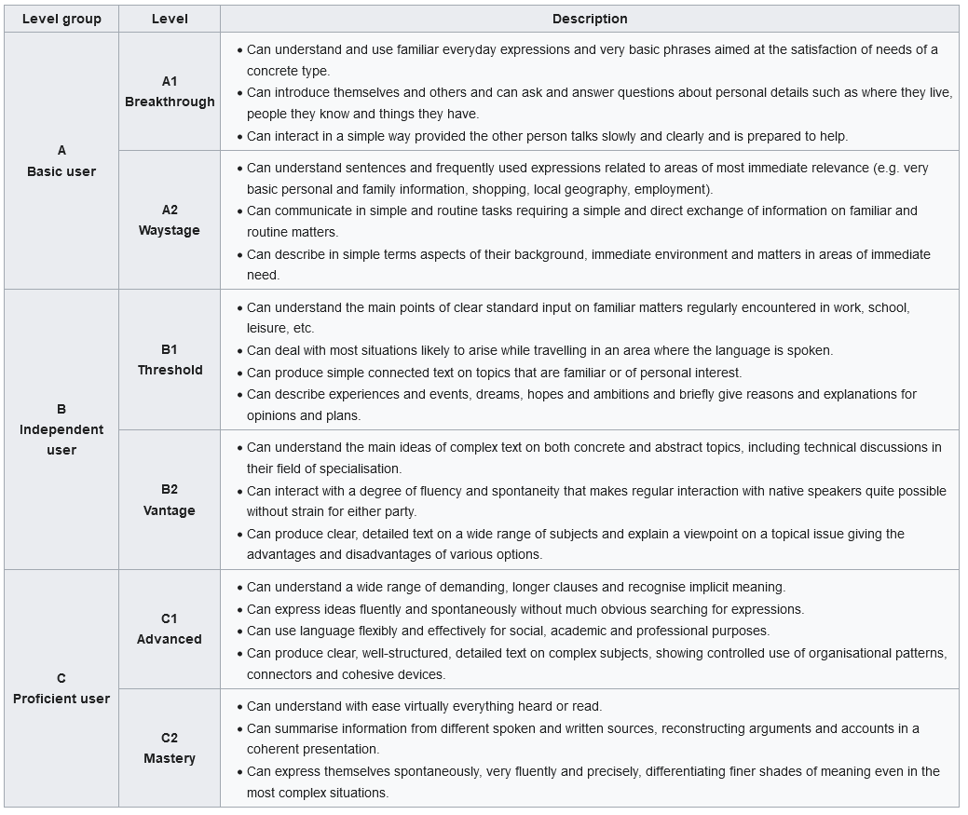

Each country or region has its own system, for example: Italy from 66 to 110; France and Belgium 10-20; Spain 5-10, Germany from 4.2 (the lowest rank) to 1 (the highest); ECTS from E to A.
Corresponding to the European Credit Transfer and Accumulation System https://education.ec.europa.eu/education-levels/higher-education/inclusive-and-connected-higher-education/european-credit-transfer-and-accumulation-system
See the table provided in this document

